**Ansible Playbook automations**

Creating play book for file creation.

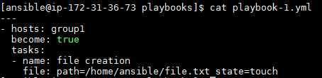

Verify the syntax of playbook.

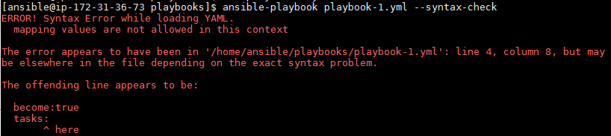

If any error occurs please cross check the syntax once and rerun the syntax.



Command to view list of host’s availability in playbook.

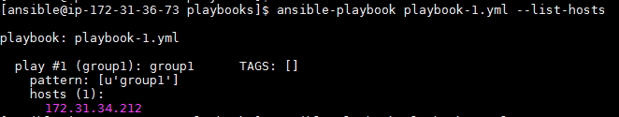

Command to run the play book to perform the task.

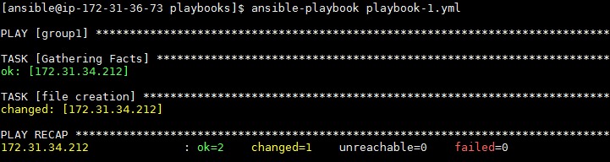

Task to perform multiple hosts.

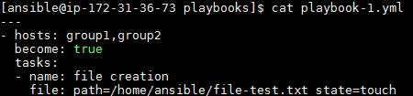

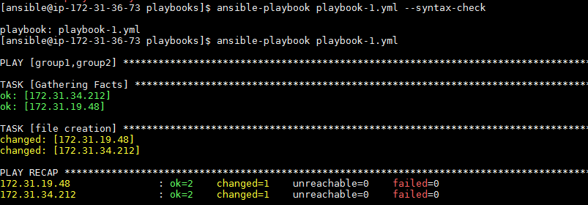

Installation of httpd package:

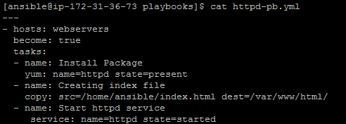

Run the Playbook

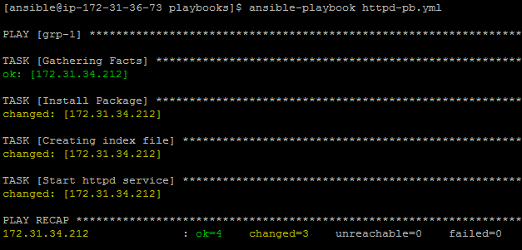

Ansible using handler:

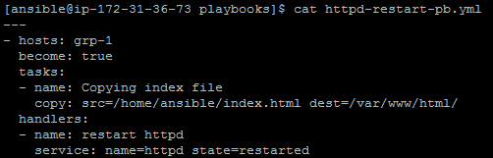

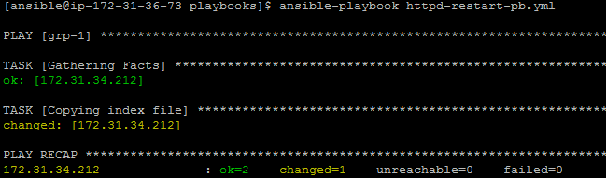

Downloading packages in playbook

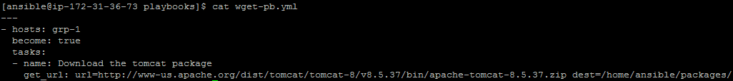

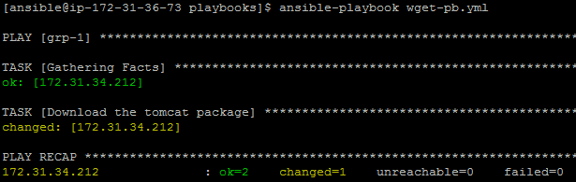

Downloading and extracting the tar bundle.

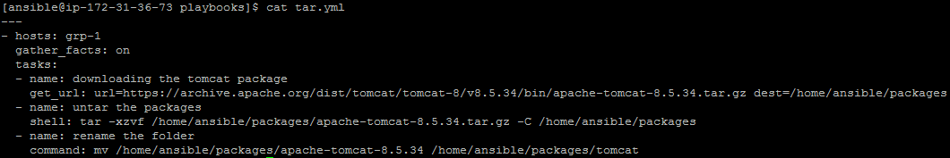



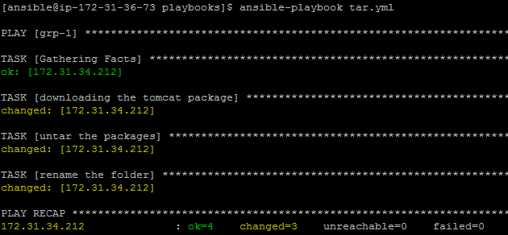

Installing Mutiple packages using playbook:

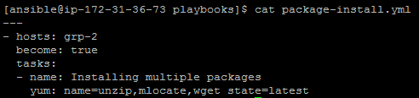

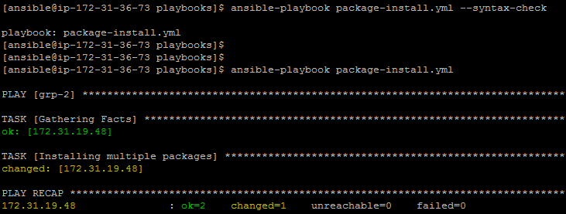

Installing tomcat using playbook

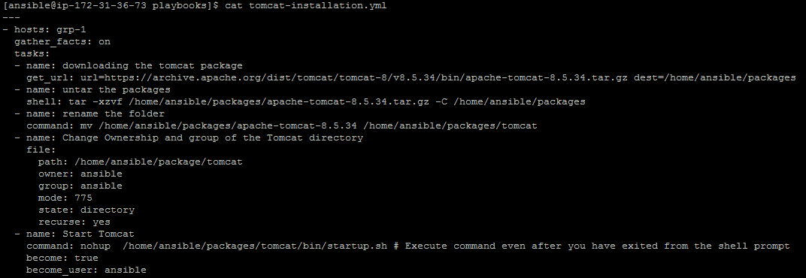

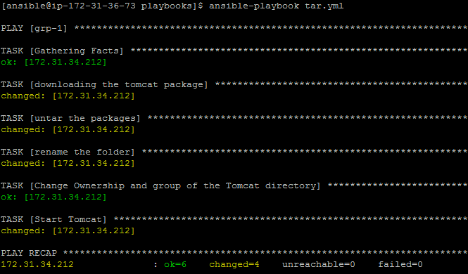

At target machine

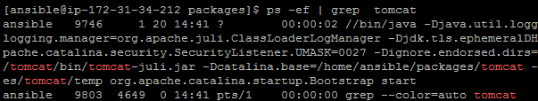

OS patching using ansible playbook

Before upgrade:

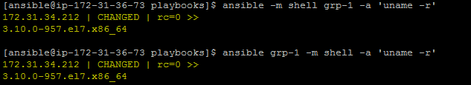

Create the script file for OS upgrade.



Playbook

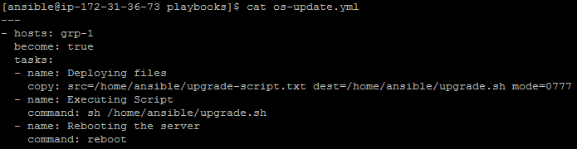

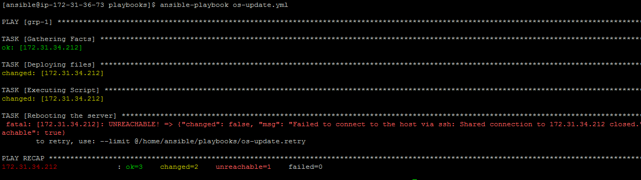

After Upgrade :

